Guidelines to format one-page abstracts for APCS 2027
Corresponding AUTHOR*, Forename B. SURNAMEª, Another AUTHOR^{b}
*Affiliation of Corresponding Author
Address of Corresponding Author
Email Address of Corresponding Author

ª Affiliation of another author if different from the Corresponding Author
^{b} Affiliation of another author if different from other authors

Abstract
This document contains information about the desired format of abstracts for peer review. Abstracts must be written in English and laid out on A4 paper size. You can produce your abstract by simply replacing the contents of this file and saving it as a PDF document (.pdf file format). Your abstract should be a single paragraph consisting of 300 words or less in 11pt Times New Roman [Style: Normal] (excluding the title, authors, affiliations, and keywords). Please include a single figure that visually represents your work. If you do include references, be sure to use the IEEE citation style as shown below. We recommend that the number of references included in the abstract phase be limited to three. (e.g. Adriaenssens et al. [1], Chilton [2], or Tibert and Pellgrino [3]). We recommended that the abstract be concise and specific. For example, consider including a clear description of the problem addressed by the research or project, a contextualization of relevant previous work and how the abstract’s contribution is new and different, a description of the methodology or approach used, and a discussion about the meaning, value, and impact of the results. There are two options for submission: (1) submitting an abstract and then a full paper and (2) submitting only an abstract. The deadline for the abstract is October 20, 2026 for case (1) and February 1, 2027 for case (2). In case (1), if your abstract is accepted, you will be invited to submit a full paper.
Keywords: Include a list in 9pt Times New Roman [Style: Keywords] of fewer than ten keywords or terms, separated by commas, using nouns or adjective(s)-plus-noun forms that are relatively standard in structural design. (For example, conceptual design, morphology, form-finding, optimization, concrete shells, metal spatial structures, membrane structures, and earthquake design.)
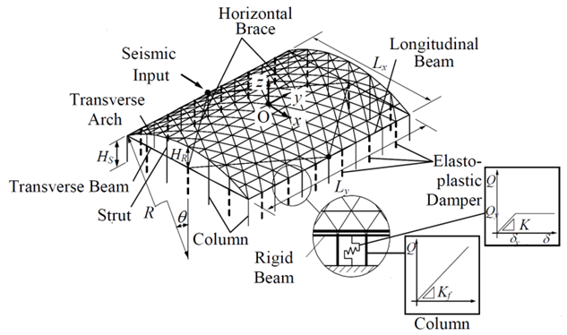
Figure 1: This is a typical figure caption. Add credits and/or references as appropriate.

References
[1] S. Adriaenssens, P. Block, D. Veenendaal and C. Williams (eds.), Shell Structures for Architecture: Form Finding and Optimization, Routledge, 2014.
[2] J. Chilton, “Heinz Isler’s Infinite Spectrum: Form‐Finding in Design,” Architectural Design, vol. 80, no. 4, pp. 64-71, 2010.
[3] A. G. Tibert and S. Pellegrino, “Review of Form-Finding Methods for Tensegrity Structures,” International Journal of Space Structures, vol. 26, no. 3, pp. 241-255, 2011.

